SELF
- self symbol
  - self start symbols
  - self end symbols
  - self means symbols
  - self reference symbol
  - self value symbols
  - self possessions
  - self human qualities
  - self ability symbols
  - self reflexive symbols
  - self type
- Self Help

SELF ARROWS
- Vector quantity
  - quantity with both magnitude and direction
  - self +
    - upward + self
    - downward + self ( vector symbol )
    - Windle
      - self rotating windle
      - process
      - self or self movement
      - displacement
    - containment
      - contained in is energy
    - Condition or conditional arrows
    - static or state
      - passive
      - indicating
of | 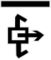
with | 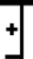
by | 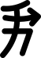
for | 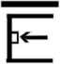
out of | 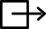
concern | 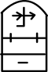
- type 2 causal
according | 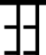
instead | 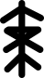
in of | 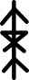
with
without | 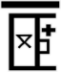
for
against | 

