WRITE
- write or draw
  - write about
  - write on mountains or pillars
  - written by
    - instrument
  - written on
    - paper
    - film
- design
- Based on the source of the Letter and the target
  - sounds same but different forms
  - sounds same and same forms
    - similar vocabulary is a family
    - but different vocabulary
- Based on the reference of
  - sounds based on indirect realism
    - sounds referring to
      - Chinese characters or logograms
  - unintelligible sounds
- Based on reference to a particular idea ( acting like itself )
  - Reference to of alphabets ( a particular word or concept)
    - ideophones
      - phonetic +
      - phonetic + pasigraphy
ENGLISH | MANTRAKSHAR
describe | 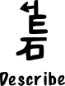
dissertation | 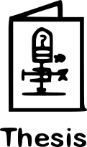
inscribe | 
inscription
newspaper |  | 
notebook | 
pen | 
pencil | 
premise | 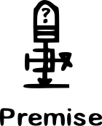
prescribe | 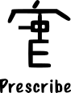
prescription
proposal | 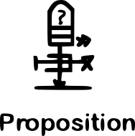
scribble | 
subscribe | 
subscript | 
Superscript | 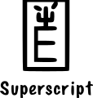
thesis
write | 

