SPATIAL MOTION PREPOSITIONS
according | 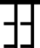
instead | 
in of | 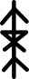
with | 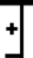
without | 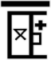
for | 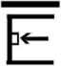
against | 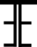
- away from symbol
- towards symbol
- about symbol

