SWORD ( MNEMONOGRAM)

NOUNS

- , knife , dagger , razor , blade , dart , scalpel , kunai ,
- , thorn , pin , needle , injection
- ray , , spear ,
- spade, axe , hatchet
- scythe
- fork
- scissor
- saw , chainsaw
- shriken ,

VERBS
bust | 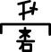
capture | 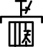
defeat | 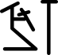
destroy | 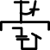
fight | 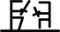
hunt | 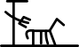
impair | 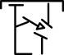
injure | 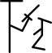
incise | 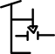
kill | 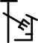
prosecute | 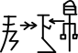
regret | 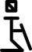

2D MENTAL

MENTAL QUALITIES
  - sharpness , inclination , instinct , intuition

ADJECTIVES
cruel | 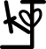
mean | 

