JUGULAR FORAMEN
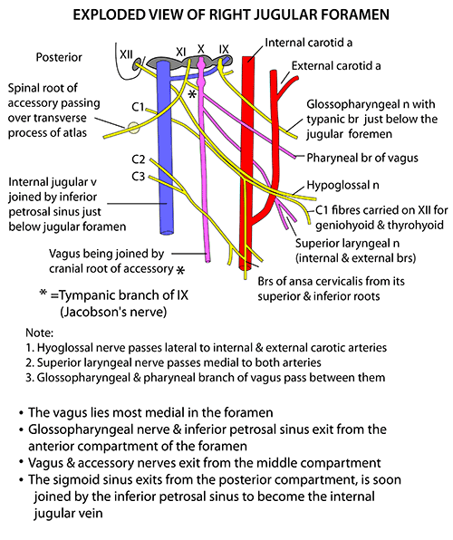

DISSECTION
A, The skin and scalp around the have reflected to expose the area lateral to the jugular foramen. The sternocleidomastoid is exposed behind and the parotid in front of the . The greater occipital and occipital artery reach the subcutaneous tissues by passing between the attachment of the trapezius and sternocleidomastoid muscles to the superior nuchal line. The external acoustic meatus is located a little forward of the site of the jugular bulb. B, Removal of the superficial muscles and parotid exposes the facial , temporalis and masseter muscles, posterior belly of the digastric, and the internal jugular vein. The sternocleidomastoid has reflected backward to expose the accessory entering its surface. C, The mandibular ramus and condyle, medial and lateral pterygoid muscles, and posterior belly of the digastric have removed to expose the styloid process, which is located lateral to the jugular foramen. The internal carotid artery ascends to enter the carotid canal in front of the jugular foramen. Both the jugular foramen and carotid canal are situated behind the tympanic part of the temporal bone, which forms the posterior wall of the condylar fossa. The tensor and levator vela palatini muscles are attached to the eustachian tube in the area below the horizontal segment of the petrous carotid. The infratemporal fossa is located below the greater of the sphenoid. The mandibular passes through the foramen ovale to enter the upper part of the infratemporal fossa. Branches of the ascending pharyngeal artery pass through the jugular foramen to supply the surrounding dura. The hypoglossal passes forward across the external and internal carotid artery. D, The styloid process has removed to expose the glossopharyngeal, vagus, accessory, and hypoglossal nerves descending between the internal carotid artery and the internal jugular vein in the area immediately below the jugular foramen. The glossopharyngeal descends along the lateral side of the internal carotid artery. The accessory passes backward across the lateral surface of the internal jugular vein. The hypoglossal passes through the hypoglossal canal, which is located below and medial to the jugular foramen, and descends with the nerves exiting the jugular foramen. The occipital artery gives rise to a meningeal branch, which passes through the jugular foramen to supply the surrounding dura, and to the stylomastoid artery, which passes through the stylomastoid foramen with the facial . (Images courtesy of AL Rhoton, Jr.)
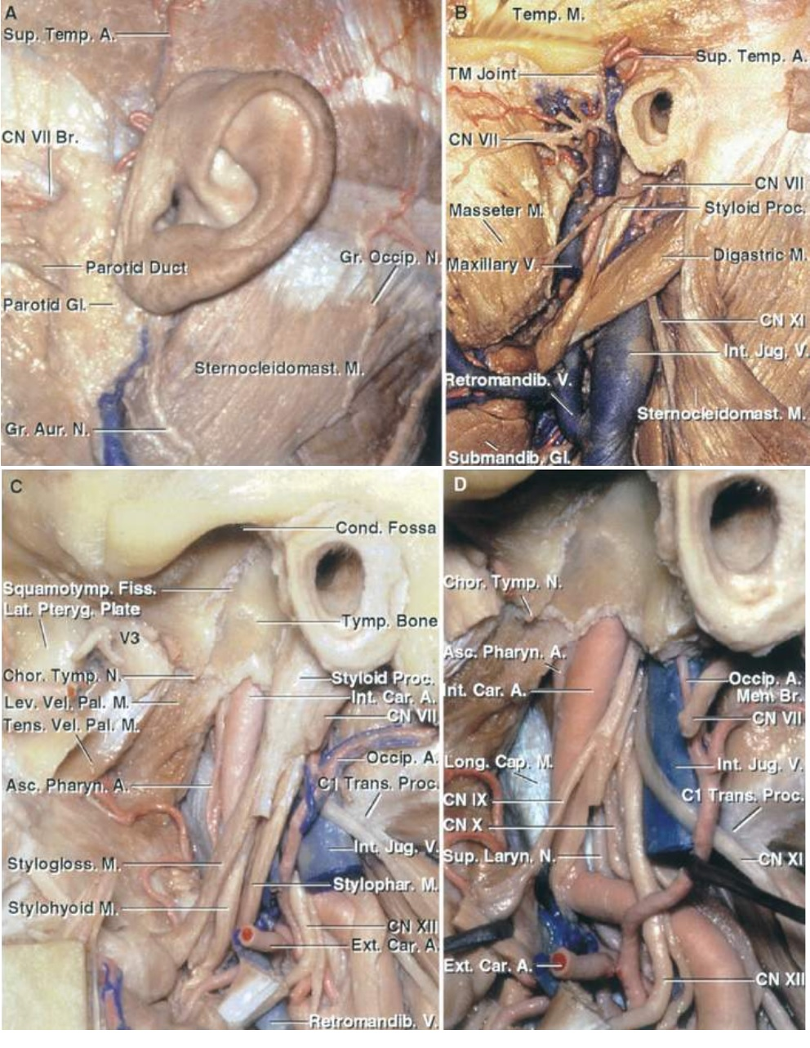JUGULAR FOSSA

