JOY
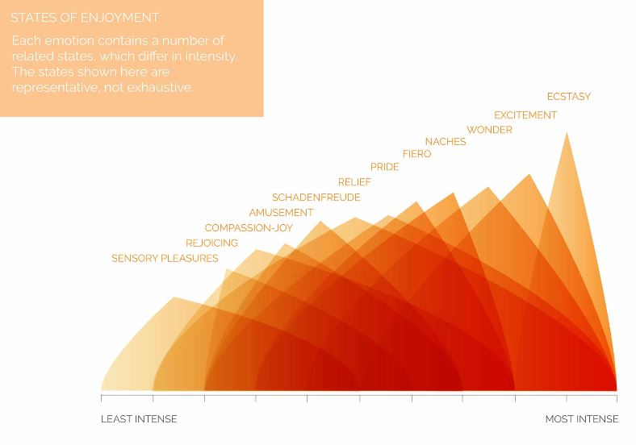
sensory pleasure
rejoicing | 
compassion | 
amusement | 
schadenfreude | 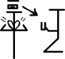
relief | 
pride | 
fiero
naches
wonder
excitement | 
ecstasy | 

OTHER HAPPY EMOTIONS
- 1.1 German derivative - happy , laughter , glee , joy , bliss
- 1.2 Latin derivative - epiphany , euphoria , jubilation , joviality
- 2.1 thrill
- 2.2 exhilaration , pleasure , ecstasy , enthusiasm , zeal
- 3.1 win
- 3.2 Triumph , victory , jubilation , conquer , successful
- rest, enough, just
- relaxation, contented , serenity , calm,
- alert
- engrossed , absorbed , meditate , concentrate , attention
- holy , godly ,religious , clean , pure , righteous
- consecrate , immaculate , sacred , virtuous
 | please , dear ,
 | thank , | gratitude
 | greed , | enchantment , attraction , infatuation , attachment , | greed is like a hungry
 | hug , cuddle , | embrace
 | kindness, , gentleness , pity , politeness , friendliness , softness , | altruism , benevolence, courtesy , sympathy, tenderness, humility, compassion , console , comfort , care, | kindness is like given by one to a needy
 | praise , | recommend , admiration , applaud , appreciate | praise,admire,applaud is like a sweet given by one to another

