FREQUENCY SYMBOLS

DEFINITE FREQUENCY

Adverbs of time (HOW OFTEN)
Here’s the list of adverbs of that modify a and tell us ‘how often’ takes , took or will take :
Definite frequency
Adverb
Hourly | 
Weekly | 
Monthly | 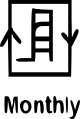
Yearly | 
Quarterly
Fortnightly
Regularly | 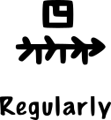

INDEFINITE FREQUENCY
Indefinite frequency
Adverb
Always | 
Daily | 
Usually | 
Frequently/often | 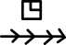
Sometimes | 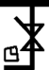
Occasionally
Rarely | 
Seldom | 
Hardly ever
Never | 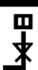
Generally | 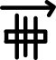
Normally | 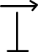
often | 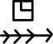

TIMED ARROWS
frequently |  | Many times
ocasionally | 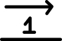 | Many times
randomly | 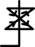
rarely
ENGLISH | MANTRAKSHAR
constantly | 
frequently
infrequently | 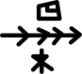
often
regularly | 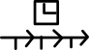
usually
incidentally | 

