ANGER
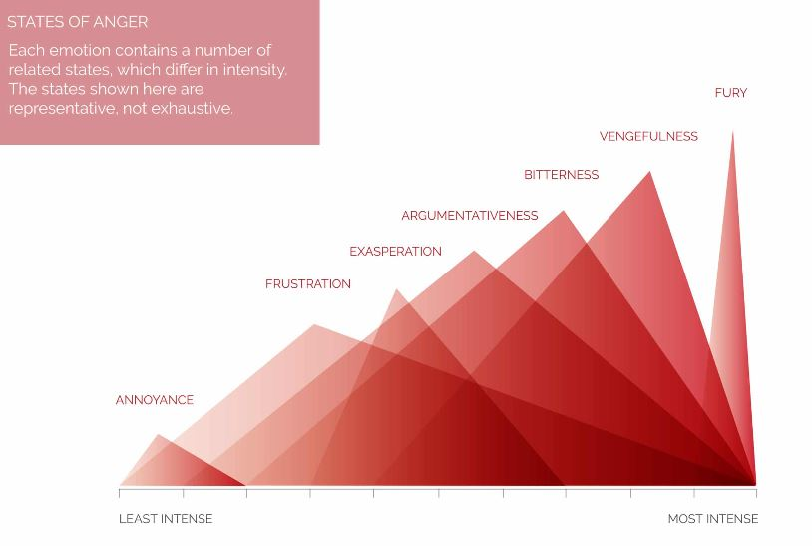
Annoyance | 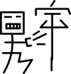
Frustration | 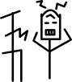
Exasperation | 
Argumentativeness | 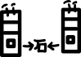
bitterness | 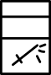
Vengefulness | 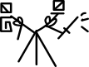
Fury | 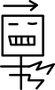
 | anger , wrath , fury , rage , outrage ,rival , ferocity , , scorn | aggression , exaggeration , agitation , vengefulness

