TETRAGON
- Enclosed space
  - resembling a mathematical figure
    - plane
      - square
      - rhombus
      - rectangle
      - Trapezium
        - bell
          - alarm or siren
boundary | 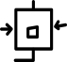
confine | 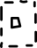
limit
wall | 

VERBS
show | 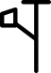
Hide | 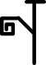
Push | 
Pull | 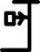
Hang | 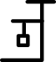
Tension | 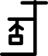
 | 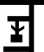
Swing | 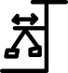
Pick | 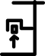
Drop | 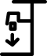

ADJECTIVES
Big | 
Small | 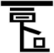
Huge | 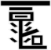
Tiny | 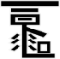
High | 
Low | 

PREPOSITION
Anterior | 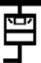
Posterior | 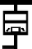
Medial | 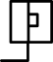
Lateral | 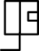
In | 
Out | 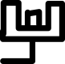
Roof |  | 
Floor | Latin plānus (“level, flat” | 

BOX
- SQUARE, Quadrangle, Quadrate, Diamond figure, Rhomb-oid, Lozenge, Parallellogram.
- Flux of a pin
  - LAMIN, Flake, , , Plank, Lath, Plate, Schedule, Scrole, Sheet, Wafer, Cake, Leant, Flap, Label, Coit.

BOX IDEOGRAMS
- 4.
  - 4.1 outside
    - OBJECT
    - Join
  - 4.2 inside lines
    - past
    - Present
    - Future
    - TIME

BOX PICTOGRAMS
  - edge modifier
    - pit
    - ELEVATION
    - case
    - HOLE
    - SUN
  - outside
    - + lines
      - hammer
      - BALANCE
  - in and out
    - FACE
  - inside
    - + line
      - Board
    - + angles
      - MONEY
    - + triangle
      - Message

BOX

BOX EDGE MODIFIERS
han | Elevation |  | Anýpsosi | Elevatio | 
ton | Depression |  | lákkos | pit | 
cun | Hole | Loch | Trýpa | Foramen | 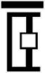
Bong | Box | Kasten | Koutí |  | 
Qian | Lock | sperren | Kleidariá | cincinno | 
shu | Sun | Sonne | Ílios | solis | 
tei | stairs | Treppe | Skáles | Scalae | 

BOX AND LINES
PASIGRAPHY | ENGLISH | GERMAN | GREEK | LATIN | MANTRAKSHAR
cheng | Hammer |  | Sfyrí | Malleus | 
sui | Object | Objekt | Antikeímeno |  | 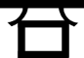
Vaa | Balance |  | Isorropía | Libra | 
yin | Join | Beitreten | Symmetochí |  | 
bai | Flag | Flagge | Simaía |  | 
nau | ship | Schiff | Ploío , nautus | Navis | 

BOX INSIDE MODIFIERS
 | ENGLISH | GERMAN | GREEK | LATIN | MANTRAKSHAR
Bua | Board | Planke | Sanída , abakos | Tabula | 
kia | Book | Buchen | Vivlío , biblio | Liber | 
wia | Message | Botschaft | Mínyma | Nuntius | 
lia | Money | Geld | Chrímata | Pecunia | 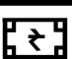
tin | Time | Zeit | chrónos | Tempus | 

NOUNS
SANSKRIT | ETYMOLOGY SANSKRIT | MANTRAKSHAR
wardrobe | from garder (“to keep safe”) + robe.
almirah | From arma (“weapons, tools”) +‎ -ārium. | 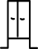
cavity | from cavus (“hollow, excavated, concave”) +‎ -tās (“-ity”
closet | From clausus (“shut, closed”), perfect passive participle of claudō (“I shut, close”) | 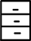
cupboard | Equivalent to cup +‎ . | cupboard
 | from Latin cella (“chamber, small , compartment”) | 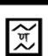
Roof
Floor | Latin plānus (“level, flat”
 | from πύξος (púxos, “ ; boxwood”))
casket | from cask + et
chest | from Ancient Greek κίστη (kíē, “chest, , basket, hamper”),
case | from Latin capsa (“, bookcase”),
suit case | from Latin capsa (“, bookcase”),
baggage | from bague (“bundle”)
luggage | lug (“to drag”)
boundary
confine
limit
wall

VERBS
show
Hide
Push
Pull
Hang
Tension
Swing
Pick
Drop

ADJECTIVES
Big
Small
Huge
Tiny
High
Low

PREPOSITION
Anterior
Posterior
Medial
Lateral
In
Out

